MCKV INSTITUTE OF ENGINEERING

Computer Science and Engineering – Data Science

***Name - Abhinaba Sarkar***

***Roll No. - BTECH/CSE-DS/2020/47***

**Assignment Number: *2***

Problem statement:

Write a python program to swap two variables using and without using third variable.

Assignment 2.a)

Source code:

a = eval(input("Enter your value for a: "))

b = eval(input("Enter your value for b: "))

print("before swapping:" ,"a=",a," ,","b=",b)

a,b=b,a

print("after swapping:" ,"a=",a," ,","b=",b)

output:

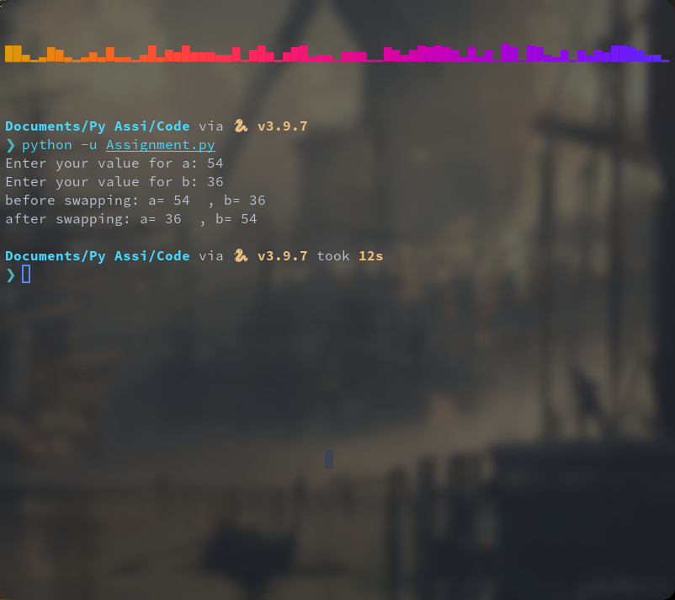

Problem statement:

Consider the basic pay of an employee as user input. AGP is 50% of the basic pay. Company provides 50% DA and 15% HRA on the merged basic. Write a python program to calculate and display total salary of the employee.

Assignment 2.b)

Source code:

basic=eval(input("enter the basic pay drawn by the employee:"))

AGP=(basic)* 50/100

mrgbasic= AGP + basic

DA= (mrgbasic)* 50/100

HRA=(mrgbasic)* 15/100

T= AGP + DA + HRA + basic

total="{:.2f}".format(T)

print("Total salary drawn by the employee=",T)

output:

